  - additional questions call: 978-265-6225

MDHA AV Projector self set up guide
This document is a brief outline of set-up instructions for AV equipment. A hands-on demonstration will be given to any board member or component who decides to utilize this equipment with out onsite support.

Projector and screen self set up guide
  - additional questions call: 978-265-6225
  - MDHA AV
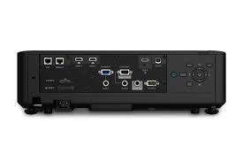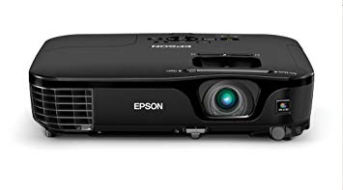
STEP 1
Set up projector screen. Remove pole by turning red tab and insert into hook at the top of the screen. Extend pole until screen unravels and is standing upright.

STEP 2
Connect your laptop to the projector via the computer port located on the back of the projector. HDMI, and VGA are available ports on the Epson Projector and corresponding cables should be used. Confirm which type of connection is needed and the cord will be provided.
Turn the projector on. The power button is located on the top of the projector. Make sure there is a power cable plugged into a nearby outlet. Once the screen is on, you will see a blue background with the Epson logo projected.

STEP 3
Turn on your laptop. Open the selected software where your presentation is located. PowerPoint presentations should be displayed in “projector mode” which is a small icon located on the bottom right corner of the software.

