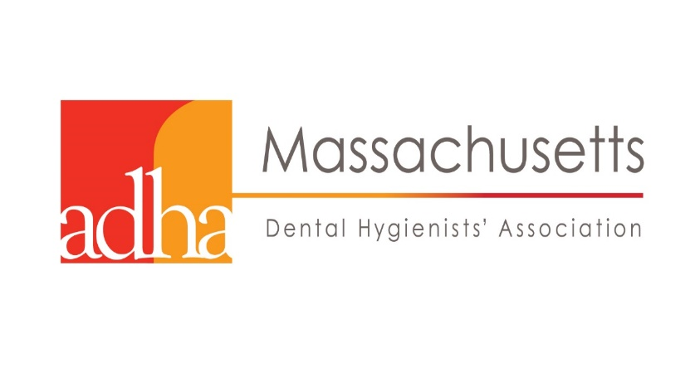

Local Anesthesia Certification Program
Middlesex Community College, Lowell, MA

Middlesex Community College has been training RDH in local anesthesia since 2005. This course is recommended for registered dental hygienists who would like to become certified in local anesthesia. MCC complies with the Mass. Board of Registration in Dentistry regulations for the administration of local anesthesia. At completion, RDH will be able to administer safe, effective, and painless local anesthesia with confidence and competence and be prepared to take the CDCA exam. The course consists of a 40 hour online study (independent and self-paced) prior to clinical training, interactive presentations, and a 3-day clinical training in which students will have 30 injection experiences and a clinical final exam. 54 CEUs. CDCA exam is a separate fee. Course director and lead instructor:
Debra November-Rider, RDH, MSDH. 24 seats available.

Enrollment begins December 4.

Questions call 781-280-3570 or e-mail Ellen at wrighte@middlesex.mass.edu

Clinic Dates: March 17, 18, 19, 2018. Online study: Through March 12
Program details

