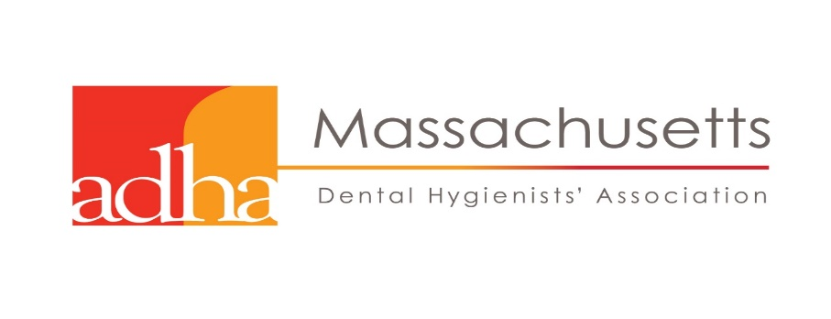

The Worcester Component of MDHA
Presents
“Fast and Furious Pharmacology Review”

Kate Soal RDH, CDA, MSDH

Saturday March 3, 2018
3 CEU's
FULL BREAKFAST & DOOR PRIZES
8:30 AM – 12:00 PM
The Manor Restaurant
42 West Boylston Street
West Boylston, Mass 01583
Members: $50
Non-Members: $75

COURSE DESCRIPTION: Fast and Furious Pharmocology Review will review the major categories of prescribed pharmaceuticals, their actions and affects along with dental specific implications
Course Objectives:
- Identify drugs by category
- Explore and discuss opioid use, addiction, and emergency treatment of overdose
- Identify drugs associated with certain medical conditions
- Discuss drug adverse effects and oral implications
- Discuss drug /drug interactions
- Identify and discuss available drug references
INSTRUCTOR: Katherine Soal RDH, CDA, MSDH started her career as a dental assistant in England in 1984, she attended Brighton Technical College and became a Registered Dental Surgery Assistant in 1986. After emigrating to the United States in 1987, Kate continued dental assisting until attending Quinsigamond Community College where she earned her Associates in Dental Hygiene in 1999, a Bachelors’ degree in Natural Science (Magna Cum Laude) from Worcester State University in 2010, and a Masters’ degree in Dental Hygiene from Massachusetts College of Pharmacy and Health Sciences University in 2014. In 2003, Kate began teaching as an adjunct at Quinsigamond Community College and in 2012 became full-time faculty lecturing in dental radiology, periodontology, local anesthesia, and pharmacology along with all levels of clinical instruction. She also is adjunct faculty at Mount Wachusett Community College teaching local anesthesia. Kate’s clinical dental
hygiene experience was gained during private periodontal practice in Worcester, MA from 1999 to 2013. Kate is a proud member of the ADHA and is currently serving as President Elect for ADHA Massachusetts.

PHARMACOLOGY REVIEW SATURDAY MARCH 3, 2018

To REGISTER, please print a copy of this message, fill out the form below, and return by February 24, 2018

CIRCLE PLEASE

Member Registration - $50.00
Non-Member Registration - $75.00

You can pay Member Registration rates by joining ADHA now at: www.adha.org

Contact Information

NAME:

ADDRESS:

CITY, STATE, ZIP

HOME PHONE: ALTERNATE PHONE:

EMAIL:

PLEASE MAIL THIS FORM AND CHECK MADE PAYABLE TO MDHA TO:

Ruthann Zamarro RDH
341 Salisbury Street
Worcester, MA 01609

Questions call Ruthann at: 508-868-8948

