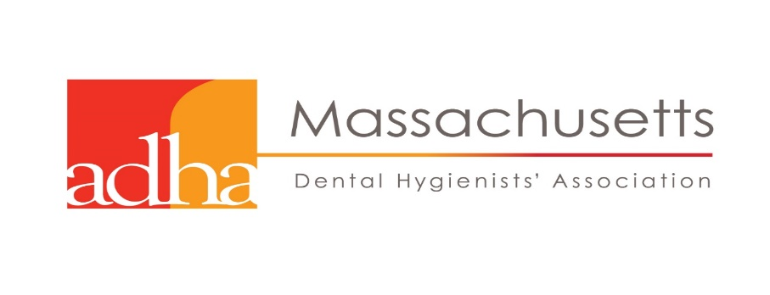

The Worcester Component of MDHA
Presents
“Management of Medical Emergencies in the Dental Office”

Dr. Peter A Vellis D.D.S.

Wednesday April 4, 2018
2 CEU's
FULL DINNER & DOOR PRIZES
6:00 - 9:00 PM
The Manor Restaurant
42 West Boylston Street
West Boylston, Mass 01583
Members: $50
Non-Members: $75

COURSE DESCRIPTION: This course will provide the dental professional training on the best practices for recognizing and managing emergencies in the dental office. This course will emphasize the prevention of emergencies through obtaining a complete medical history and modifications to treatment based on this medical history. Recognition and management of emergencies will be addressed in order to manage the patient until they recover or helps arrives

INSTRUCTOR: Dr. Vellis is a Diplomat of the American Board of Oral and Maxillofacial Surgery, a Fellow of the American Association of Oral and Maxillofacial Surgeons, Fellow of the American College of Oral and Maxillofacial Surgeons, and member of the American Dental Association. He specializes in dental pathology, trauma, implants, and extractions.

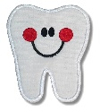

MEDICAL EMERGENCIES WEDNESDAY APRIL 4, 2018

To REGISTER, please print a copy of this message, fill out the form below, and return by March 28, 2018

CIRCLE PLEASE

Member Registration - $50.00
Non-Member Registration - $75.00

You can pay Member Registration rates by joining ADHA now at: www.adha.org

Contact Information

NAME:

ADDRESS:

CITY, STATE, ZIP

HOME PHONE: ALTERNATE PHONE:

EMAIL:

PLEASE MAIL THIS FORM AND CHECK MADE PAYABLE TO MDHA TO:

Ruthann Zamarro RDH
341 Salisbury Street
Worcester, MA 01609

Questions call Ruthann at: 508-868-8948

