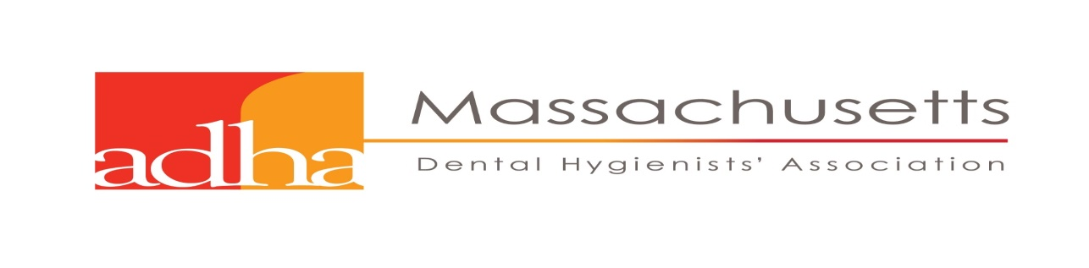
MARY DOLE SCHOLARSHIP
Purpose
The Mary Dole Scholarship supports a dental hygiene student currently enrolled in a Master’s Degree level program who has demonstrated academic excellence in dental hygiene.
Overview
Each year the American Dental Hygienists' Association of Massachusetts will award a dental hygiene student $500.00 which will be applied to tuition and fees.
Eligibility Requirements: Applicant must
▲ Be a permanent resident of Massachusetts regardless of school
choice
▲ Be enrolled at an accredited U.S. Dental Hygiene School Master’s Degree Program
▲ Demonstrate, through personal activities and achievements, a strong interest in
dental hygiene
▲ Possess a superior academic record. The cumulative average must be 3.5 or higher
▲ Be a current member of the American Dental Hygienists' Association

Application Process Checklist
Applicants must submit the following items on or before
▪ Two letters of recommendation (in a word document).
▪ An essay of the student’s insights he/she has gained from achievements and activities
in dental hygiene. The essay can indicate future career goals in dental hygiene.
The essay should be 1000-1200 words, double-spaced in a word document.
▪ A current curriculum vitae.
▪ Transcripts obtained from candidate's school verifying academic standing.

Application Deadline
All Applications must be received on or before July 1st, 2018.

Submit to:
Virginia Heroux
MDHA - Council Chair of Education and Research
Email address: vmhmme@aol.com

